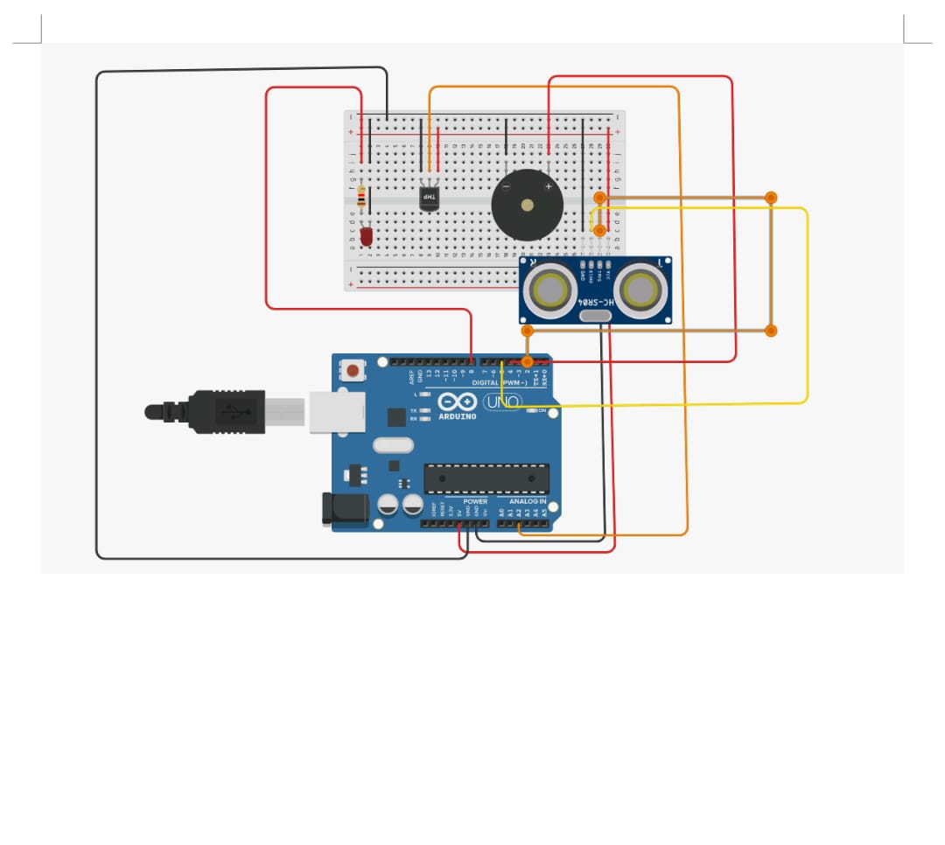int led = 8;

int trig = 2;

int echo = 5;

int buzzer = 4;

void setup()

{

Serial.begin(9000);

pinMode(led,OUTPUT);

pinMode(trig,OUTPUT);

pinMode(echo,INPUT);

pinMode(buzzer,OUTPUT);

}

void loop()

{

double a = analogRead(A2);

double v = a / 1024;

double tvolt = v \* 5;

double o = tvolt - 0.5;

double t = 0 \* 100;

Serial.print("Temperature in degree");

Serial.println(t);

if(t >= 50)

{

digitalWrite(led,HIGH);

}

else

{

digitalWrite(led,LOW);

}

digitalWrite(trig,LOW);

digitalWrite(trig,HIGH);

delayMicroseconds(10);

digitalWrite(trig,LOW);

float dur = pulseIn(echo,HIGH);

float dist = (dur \* 0.343)/2;

Serial.print("Distance");

Serial.println(dist);

if(dist >= 17)

{

digitalWrite(buzzer,HIGH);

}

else

{

digitalWrite(buzzer,LOW);

}

}